Problem statement:

The main aim of this project is to develop an interactive website that facilitates the customer with an on-the-clock functionality which is useful to find sweets for any occasion with different categories like sweets, premium sweets, assorted sweets and make your own box, etc. and the customer can buy them at any time from anywhere.

The aim of this application is built for the customer who are unable to reach to the shop so they can easily go through the website and order their favorite sweets from anywhere and they can enjoy the festival or any occasion etc. with their favorite sweets from their permanent shop

Requirements:

* A Login and registration facility for enabling access to the system both for customers and Admin.
* The customer can view/search the Sweet Categories without logging into the system or getting him/her registered.
* To buy Sweets, the user should follow the registration (login) process.
* The administrator will maintain the system through the admin panel which consists of order bills, order Status add/update/delete the product details in the catalog.

Features:

* An online sweets shop that allows users to check for various sweet categories available at the online shop and purchase online.
* The project consists of a list of sweets quantity and sweet categories displayed with their prices.
* The user may browse through these sweet categories as per his/her requirement.
* If the user wants to buy sweets he/she may add it to his/her shopping cart.

Technologies:

* HTML, CSS, Bootstrap (Front-end)
* MYSQL(Backend)
* Python, Django (Server-side programming)

Modules:

* Home
* About Us
* Services
* Contact Us

User Case Diagram: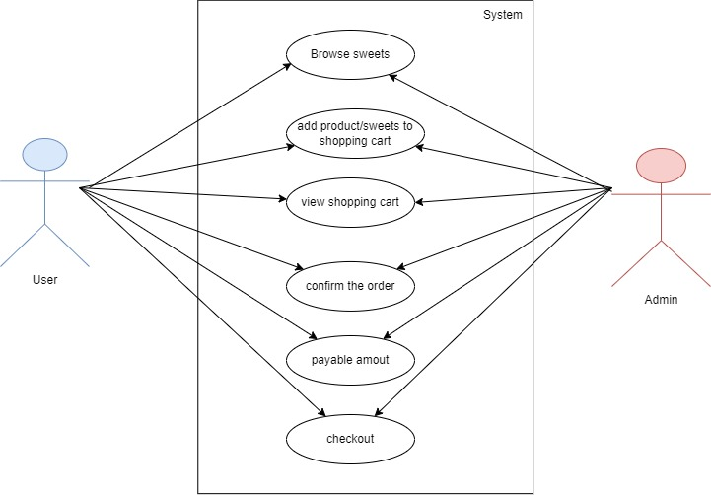

Class Diagram: 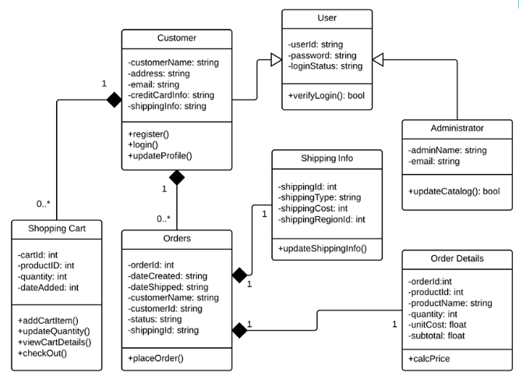

Sequence Diagram: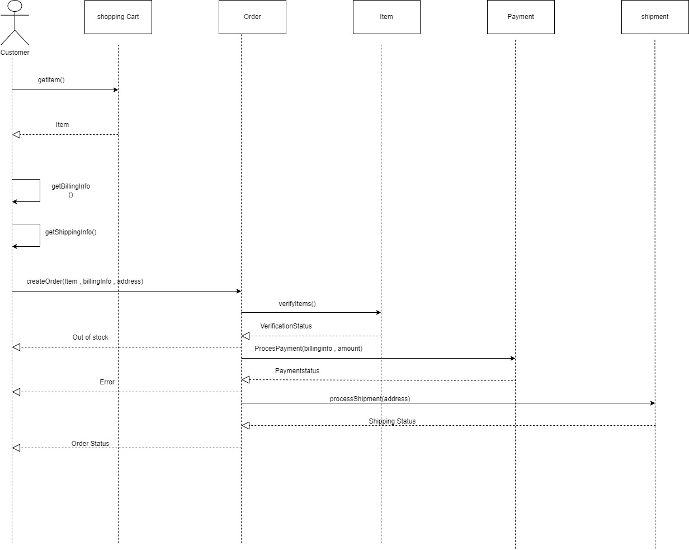

Future Scope:

Our designed online shopping system provides a 24×7 service, that is customers can surf the website, place orders anytime they wish to. Also, the delivery system works 24×7 hours a week. Some of the features that can be modified and added to this system in the future involve its implementation.